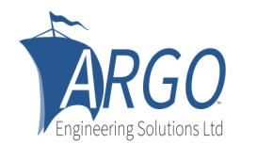 | ENTRY FORM  MINI-40 OPEN MEETING  Fast, Fun, Fantastic! | 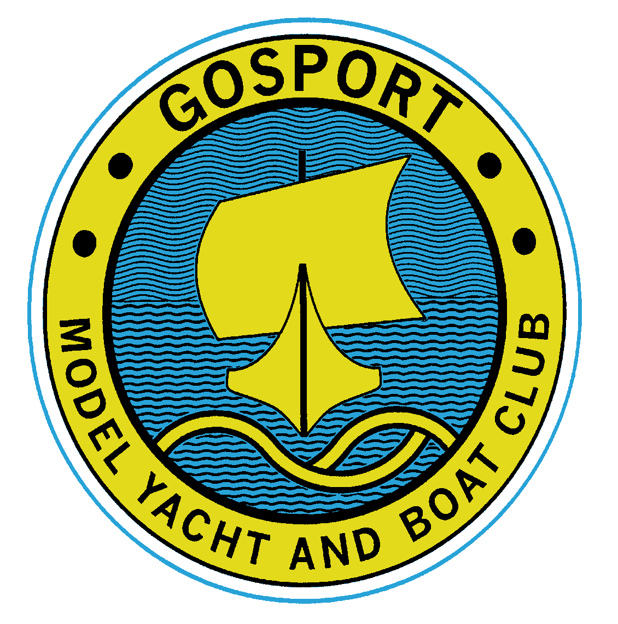
SATURDAY 11th AND SUNDAY 12th APRIL 2026
At Gosport Model Yacht and Boat Club
Name | Phone Number
Address | Mobile Number
Address | E-mail
Post Code | Club
Country | Model Yachting Association GB Number
Any Medical conditions the race organisers should know about: eg, Diabetic, Allergies etc.

Emergency Contact Details in case of accident
Name: | Relationship (eg spouse, partner, friend etc)
Telephone Number | Mobile Number
Disclaimer.
Competitors participate in the event entirely at their own risk. There is NO medical cover provided or implied by the organising authority who will not accept any liability for material damage, personal injury or death sustained in conjunction with or prior to, during, or after the event.
Condition of Entry
It is a requirement that you have adequate insurance cover see Notice of Race (NOR) section 2 Please complete one of the following:
- I am a member of the MYA and therefore covered by their insurance. | Signature
- I am a full member of GMYBC and therefore covered by their insurance. | Signature
- I am not an MYA member and/or am a foreign competitor. I have valid third-party liability insurance with a minimum cover of five million pounds sterling or the equivalent and will be able to produce evidence of cover at the event. | Signature
Boat Details
Name of Boat | Type (eg cat, tri)
Design | Sail Number
Designer | Radio Frequencies

I consent to have any images of myself or my boat used for publicity or other purposes. Yes / No
I am a qualified first aider and prepared to help if needed. Yes / No

Entry Fee
The entry fee is £20.00 preferably to be paid:
Via bank transfer:
Account Name: GMYBC
Sort Code: 30-93-56
Account Number: 46461560
Please use this reference and ensure your own surname and initial is included
MULTIyour surname. For example: skipper Fred Bloggs ------ MULTIBloggsF
Please contact Jacque Cook, details below, for alternatives, if this causes you a problem.
Evening Meals
Free fish and chip supper on Friday 10th of April  2026 | Attending? Yes / No | For how many people?

Might you be interested in an evening meal out on Saturday 11th of April 2026?  Further details will follow depending on numbers. | Interested ? Yes/No | For how many meals?

PLEASE RETURN THIS COMPLETED FORM AS SOON AS POSSIBLE AND NOT LATER THAN FRIDAY, 3rd OF APRIL. TO jacquecook48@icloud.com or by post to Jacque Cook 14, St Helens Road, Hayling Island, Hants, England PO11 0BT. Note, this entry is not complete until the entry fee is paid.
Declaration
By submitting this entry I agree to abide by the Model Yachting Racing Rules as set out in the Notice of Race.

Signature: Date:

