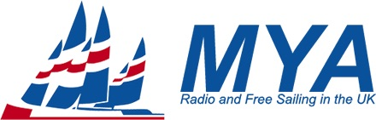
Change of Ownership Declaration Form

This form should be used when a certificate ceases to be valid upon change of ownership, and
if either
  - the certificate cannot be found for a boat obtained by a new owner,
or
  - there is no space for change of ownership declaration on existing certificate.
please delete as appropriate

After correct completion of this form, the new owner shall return it to the relevant class registrar. For IOM class please email it. For other classes send it by post together with a stamped addressed envelope and where possible with the certificate. On receipt of these documents, the registrar may issue a new certificate.
BOAT DETAILS
Class
Registration Number
Boat Name
(if to be different)
Previous Owners Name
(capitals or typeface)
New Owners Name  (capitals or typeface) |  | MYA No
If IOM, Indicate Rigs to be Included on Certificate. | A ☐ B ☐ C ☐

NEW OWNER DECLARATION
I undertake to maintain this boat in compliance with the class rules and that alterations or repairs to equipment required by the measurement form(s) to be certified will be checked by an official measurer before use.
Signature |  |  | Date
Address
e-Mail
Landline No. |  | Mobile No.

