V11 Set Up Guide
Welcome to the Set Up Guide for the V11 Vickers designed International One Metre.
This guide outlines the recommended set up details for the V11 to assist with a quick set up and
tune to help achieve optimum performance for your regular racing. Good luck! Enjoy your sailing!
RC Sailing

Hull Set Up
Keel Installation- Locate the fin into the bulb and fasten with the M4 Cap screw provided, then
insert the fin to the hull and secure with the M3 screw provided. No need to over tighten.
Rudder Installation- Insert the rudder and slide the tiller arm down over the shaft. Tighten the cap
screw onto the shaft. Check that is swinging freely. You may want to space the rudder down from
the hull with a temporary piece of paper to prevent binding on the hull when rudder is off centre.
Drop in your rudder servo with the spline forward, and secure with the M3 screws provided. Slide
the steering push rod into your desired hole on the servo horn. Usually you would use the furthest
hole from the spline to achieve lots of throw. Only instal the horn onto the servo once your
electrics are fired up and centred which may come a bit later.

A sticky back dacron sticker will needed to cover and water tight this hatch once ready to sail. A
digital servo is recommended for more accurate centering. About 5-8 kg torque.
Winch Installation- The winch tray is cut for an RMG winch. Install the winch with the M3 screws.
It may take some jiggling to get into position and possibly the need to squash the wiring a bit
flatter underneath to allow room.

For your winch line, cut an over length piece of line and thread the ends in through the exit tubes
at the back end of the boat and pick up the ends inside the hull. Thread the inboard line through
the fairlead that protrudes off the mainsheet post. This will be the return line which will go around
the bottom groove of the drum on the port side (clockwise). The other line will go direct to the top
groove of the drum, anti-clockwise. Give each line about 4-5 turns on the drum and instal the
drum. You may like to temporarily apply some tabs of masking tape each side of the drum to hold
the lines captive for when they might go slack and want to fall off. Set up and terminate the ends
of the line above deck as per the diagram, threading through the deck eye and using a rubber O
ring to keep tension. Once you are happy with the set up, be sure to remove drum before
powering up the winch. You may need to follow the winch set up guide to set travel on your winch
but in short, set your transmitter to maximum in position so the winch comes to maximum possible
in position, then reinstall the winch drum with the O ring wound as far aft along the deck as
possible. You will be able to make the main and jib sheet to suit this position. A dab of sealant can
be knifed into the exit tubes for water proofing. Leave it overnight to cure before running the winch
again.

Sheets- The threading of the main and jib sheet may be seen in the pictures. The mainsheet will
start at the winch line and thread through the same deck eye as the winch line and then through
the main post. The boom band should be aft of the post.
The jib sheet starts at the winch line and threads through the outboard deck hoop and then
through the centreline hoop on the foredeck. Forward one for A Rig, middle for B and aft for C. I
like to use the next closest hoop as a leader. Bring your winch line in to your “max. in”position and
establish your sheet lengths. Make the lines as long as you can get away with, since dyneema
line shrinks over time.

Battery- You should velcro the battery onto the stand below the main hatch. I like to use a 2 cell
7.4 volt Lipo around 1800mha.

Receiver- Your receiver can velcro under the deck just aft and starboard of the hatch.
Hatch Application- When attaching the plastic hatch for sailing, place it in position and press the
rim down with one finger and slide around the hatch until the entire hatch sits flush on the deck.
Check that it is properly down. Be sure to preserve the fibreglass rim of the deck hatch, since
scratching with a screw driver or similar will damage its water tight integrity.
Your mainsheet post is adjustable in height. You can remove it and tighten the nut against the O
ring to increase the friction.

The mast ram adjusts by turning the white plastic wheel.
The forward most eye on the foredeck is for your A rig jib swivel attachment. The 2nd back is for B
rig and 3rd for C rig.

Floatation
Your hull corrector weight which incidentally will be done last of all once you know the finished
weight of the boat, should be split into 2 pieces. They should be placed either side of the centre
case as far forward as they can go against the keel frame. You will need to remove the winch to
access this. With corrector weight attached in the hull, the 4kg yacht ready to sail should float with
the transom corner kissing the water surface. The waterline forward should be about 40mm back
from the bumper.
This should complete the basic set up of the hull.

Rig Set Up

Mast Pre Bend
The recommended pre bend for the A Rig should be 8mm over the top 650mm.
The recommended pre bend for the B Rig should be 5mm over the top 600mm.
The recommended pre bend for the C Rig is none.

The amount of bend is a measurement from the mast head to a projected straight line of the
bottom unbent part of the mast.

The amount of pre bend shown is low, and you may prefer more, however the idea is that with less
forestay tension your jib boom clew will lift more easily and open the jib leech in a gust or stronger
breeze. An auto trim function. Too little weight on the jib boom end and the boat will round up.
Firm side stays and appropriate spreader angle should keep the forestay tension in check with
these provided measurements.
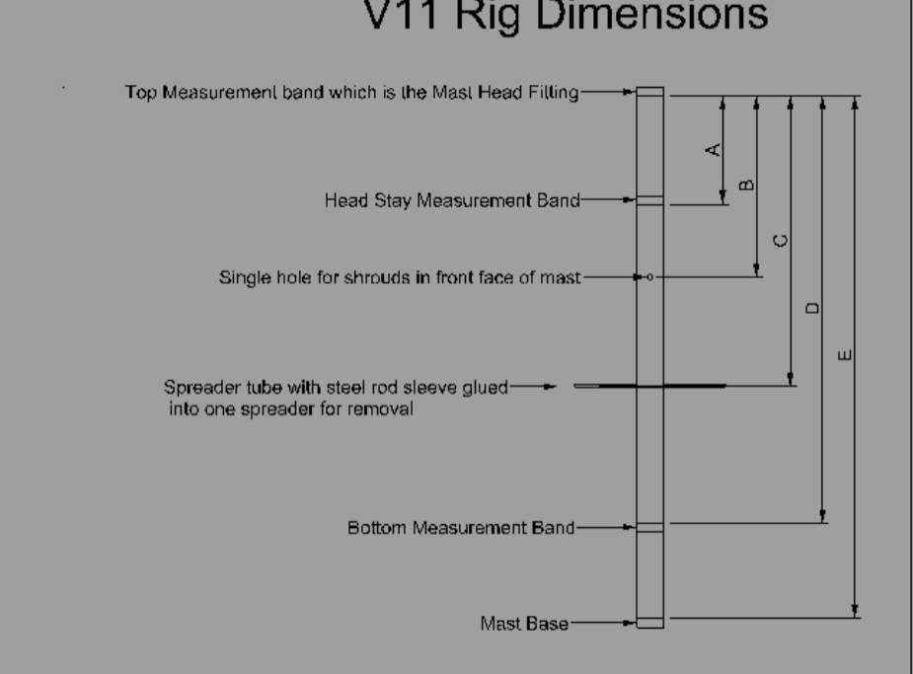
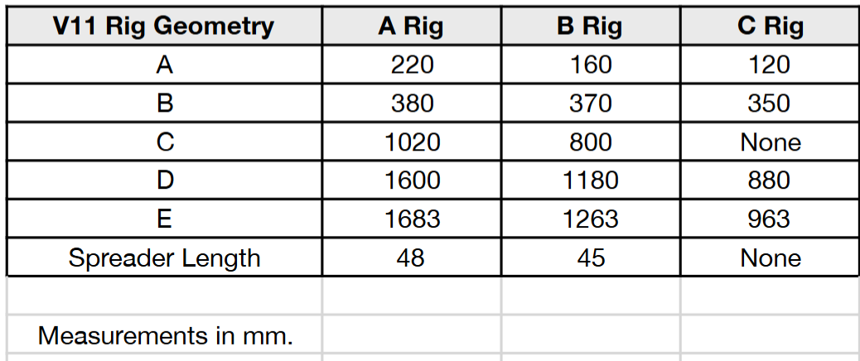
Mast Base- A Mast Base will need to be made by cutting a slot into a Bantock Mast Head Fitting
2mm deep and 1.5mm wide to suit the 1.5mm diameter rod of the mast step. Suggest to use a
needle file or similar. This then needs to be glued into the mast “dead square” to the prebend. To
find “dead square”, balance the mast horizontally resting on the masthead and mast base
between a couple of wooden blocks or similar. Let gravity work for you to help find the Mast Base
orientation. Align the mast base slot horizontally.
Gooseneck- The mast gate of the V11 is 11mm wide to provide a neat fit against the mast. A
Bantock gooseneck is wider than this and will need to be dealt to with a file in the required area to
sit inside of the mast gate when in position. File this rebate before attaching it to the mast. See
Picture. You can make the raw aluminium black again with cunning use of a vivid marker.

Spreaders- The Spreaders need to be rigid. I like to make them from stainless or brass tube with
1.5mm inside diameter and with a 1.5mm stainless rod connecting them through the mast and
glued into one of the spreaders so they are removable. They may need some angle backwards
although I mine have ended up virtually straight. Use the following method to find an appropriate
spreader angle.

Get the mast centered sideways in the boat, with max. side stay tension. Site down the mast on
both tacks to ensure it is centered.

Adjust ram and backstay so the mast suits the mainsail as best you can. There may well be a flat
spot in the middle of the mast at the spreaders, so carefully bend the spreaders aft until the flat
spot looks uniform.

The captive pins holding the shroud at the spreader ends should be crimped into the spreader
end to keep the orientation of the spreader angled aft. My captive pins are side stay wire bent to a
U shape with a bend radius that suits the side stay diameter. If done accurately, the jib topper
should not catch the spreader, although it is recommended to have a bungie on the jib topper to
manage the slack in the line when the jib boom lifts.

Forestay height should be as high on the mast as possible (close to the band), and the backstay
crane kept as short as practical. This helps achieve maximum forestay tension.
Side stays should hook into a single hole in the front of the mast. I use 105lb monofilament wire
with a tightish bend of about 1mm radius and a 30mm tail. They hook straight into the hole in the
mast. It is good to hold them captive with a piece of tape so they dont cross over.
Mast Rake is measured from the head stay measurement band on the aft face of the mast, to the
transom. Note- your lower measurement point should be 23mm above the foredeck. If its more,
add the difference to the rake measurement and if less, subtract it to get you in the ballpark.

Rake Measurements-
A Rig - 1508mm
B Rig - 1160mm
C Rig - 922mm

Main Boom- A round section is shown in the picture which is more flexible than the rectangular
Bantock one. This is personal preference but I like to be a bit flexi and light weight.
The boom sheet band should be aft of the post and lead aft for the sail relationship geometry to
be correct for downwind in comparison to the jib.

The Vang attachment along the boom should be about 100mm from the forward end.
I like to use a jackstay on the main luff. The jackstay attaches to the mast head swivel. The tension
adjusts at the bottom via the line and bowsie system slung under the gooseneck.

Jib Boom- Jib booms can be Bantock superlight sections or preferably a 10mm arrow shaft
section. If you can get away with no holes drilled it can reduce fatigue. I hook the jib sheet onto
the sliding ball set up that can hopefully be seen in the picture.
Keep jib booms as short as possible and set the gap to the mast at about 15mm for A Rig, 10mm
for B Rig and 5mm for C Rig. This determines the swivel position on the boom.
The jib sheet band should be about 10mm forward of the jib sheet hoop on the deck when the jib
is held on centreline and sitting up.

Note- When installing the rig into the boat, lean the mast back and locate the mast butt onto the
step 1st, then bring the mast forward into the mast gate. Preservation of the mast gate is
important.

Raceday Set Up and Trim
The following Sheeting Measurements for booms are measured from the edge of the boom to
centreline. So for mainsail it is to the centre of the post, and to centreline of mast for the jib.
The main twist is from the middle batten to the backstay and measured when the sail is relaxed.
This mainsail twist measurement is difficult to get accurate and may vary boat to boat with sail
shape and boom flexibility etc. so common sense is needed. If the boat has weather helm, ease
the vang and vice versa. Adjust until the boat feels balanced. In smooth air, the boat should sail
pretty much thumbs free.

The jib twist is measured at the top seam leech to topping lift.

Baseline Settings for Sailing
The measurements below will ensure a good relationship between the sails, and we can adjust
from here for other conditions.
The Baseline Settings are “maximum in” positions for your general mid range sailing upwind when
the boat is powered up and at full heel or nearly full heel and flat water. Dont be shy to ease from
here as the wind increases.
Luff tension should be just enough to take the out the slack, not necessarily under any real
tension.

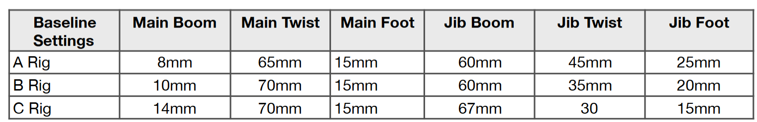

Light Air- Between the wind range of slightly heeled to 3/4 heel, we need to bring the mainsheet
in. Just like we do on a full size boat to power up and heel the yacht. Bring the mainsheet in to
5mm instead of 8mm. Your main twist will change to about 50mm. As the wind gets to the lower
end of this range, make sure the jib is not chocked. Maybe ease to 65mm. Sail luffs should be soft
and as loose as you can get away with. Increase jib foot round to 35mm.
Super light Air- Same as light air settings but keep the jib open to 65 - 70mm or more when the
wind gets to drifting conditions. Also we need to ease our sails (on the radio) in the very light air.
Maybe up to 30mm or so in the super light air when the boat is slow and fully upright. Luffs loose
and jib foot round keep at 35mm.

Fresh Breeze- Tighten jib foot to 10mm and tension the luffs. Ease out the sheets on the radio to
reduce sideways force (leeway) and allow the boat to spring forward to overcome drag off the rig
and sails. Depends on conditions but you can ease up to 40mm when in extreme gusts or
conditions.

Analyse the conditions you are sailing in. If the wind is steady and laminar flow you will get away
with sailing with a tighter main leech than a shifty turbulent wind flow. A tight main leech in shifty
turbulent wind will make the boat grouchy and weather helmed, so ease the vang to neutralise the
helm, keeping the jib loaded to allowing better acceleration and kinder response to headers.
I hope this set up guide has been useful and assists you to reach your V11 potential swiftly.
You should find the V11 to be a forgiving and easy yacht to sail and therefor be able to manage
different venues, winds and conditions well.

Enjoy your sailing and dont over think when in the heat of the battle. There are many elements to
yacht racing so try to keep a “big picture” focus. Get in space. Sail fast. Anticipate wind and fleet
as best you can. Be Patient. My few last words of wisdom 😬
All the best with your set up and sailing
Regards
Ian Vi

