Portable Boat Stand

Here is a easy to build stand to take to the pond with you. It folds up into itself so it takes almost no space in your car, van or truck.

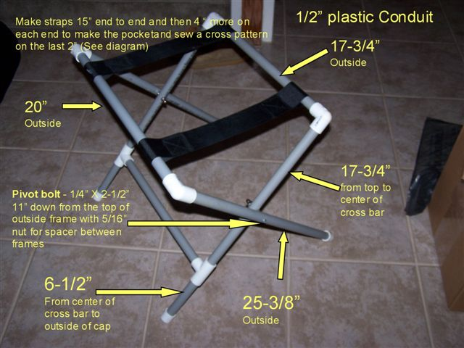

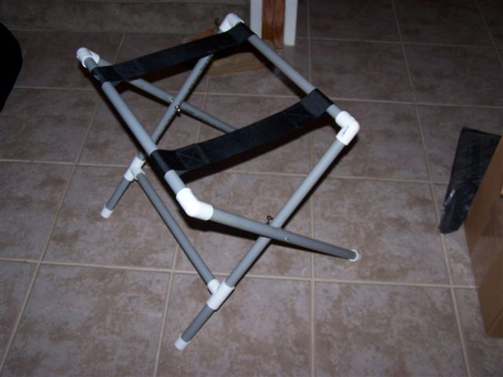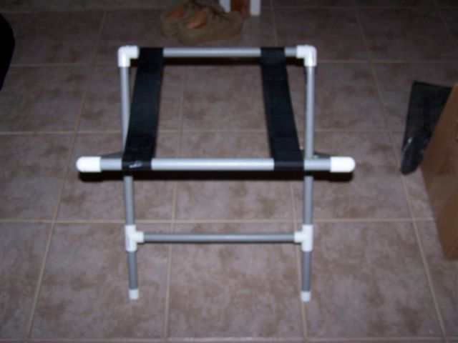

Cut two straps from 2-1/4 “ strapping/ribbon material
available from a fabric store. Raw length of each strap is 24”.
They should be installed on the top bars before any assembly of the
frames as this dimension makes them very hard to get over the corner fittings
after they are in place and it is impossible to put them on after the keel
cross bar is glued in
15”
Appx. 4”
Appx 2”
Boat Stand Straps.

