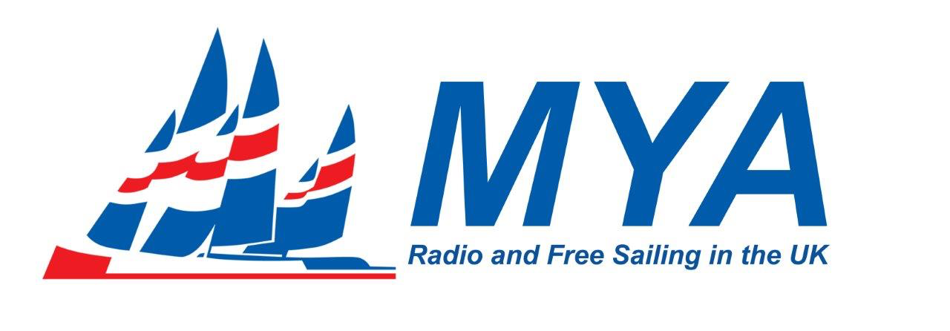

36” CLASS RULES

Introduction of this document to COG members
This is a proposed version of 36” Class Rules for 2022 bringing them into line with Standard Class Rules format and Equipment Rules of Sailing terminology.
Errors and omissions in previous class rules have been raised with Martin Dovey, Class Registrar, who is supportive of this version.
Text in this colour is new or substantially revised text.
Text in this colour is original text.
The major part of the revision is to place all the class rules that the competitor needs to comply with at an event in Section C which is presented at the front of the document.
Sections D, E and F (there is no Section G) deal with rules that apply to the boat at certification.
Section A, the administrative section, is presented last.
V3
Official Measurer replaced by class measurer.
Clause labelling extended so C.2.1 (a) is same as for M and A Class so that FSCRS text is simplified.
C.5.1 (d) amended in line with 2022 IOM CR to prohibit use of vane gear on rc boats.

PART I – ADMINISTRATION – see page 3

PART II – REQUIREMENTS AND LIMITATIONS

The competitor and the boat shall comply with the rules in Part II when racing. Measurement to check conformity with rules of Section C is not part of certification control.

The class rules for the MYA 36” Class are open class rules in which anything not specifically prohibited by the class rules is permitted. Individual rules may require, limit, or permit as necessary.

Certification shall be carried out in accordance with the ERS except where varied in this Part.

Section C – Conditions for Racing

C.1 GENERAL
C.1.1 The following ERS rules shall not apply:
(b) B.2 Headsail Booms.

C.2 COMPETITOR LIMITATIONS
C.2.1 (a) One competitor only shall control the boat.
C.2 1 (b) The competitor shall not be substituted during an event.

C.3 BOAT
C.3 1 (a) Except as in (b), (c) and (d) the boat, in racing trim, shall be capable of fitting into an open topped rectangular measurement box of internal dimensions 940mm (37") long, 229mm (9") wide and 279mm (11”) deep.
C.3 1 (b) The rig, sail(s) and hull fittings, including such parts as hatch coamings, radio gear containers and related removable hatch cover(s) may project above the plane of the top of the measurement box.
C.3 1 (c) The rudder(s) may be rotated about the normal axis (axes) of rotation and lowered along the axis (axes) of rotation with the shaft(s) within the trunking(s), for fitting within the measurement box.
C.3 1 (d) Except that their rudders may extend outside of the measurement box, boats measured before 31st December 1983, shall comply with these class rules.

C.4 WATER
C.4.1 Bilge water shall not be used to trim the boat, but may be removed at any time.

C.5 EQUIPMENT
C.5.1 (a) No hull appendage or ballast replacement shall be used during an event, except in cases of authentic damage or loss. All replacements shall be authorised by the race committee.
C.5.1 (b) Except for boom counterbalance weights, ballast shall not be changed, moved or rotated relative to the hull.
C.5.1 (c) More than two channels of radio control are prohibited.
C.5.1 (d) Any other form of remote control and or automatic control is prohibited.
C.5.1 (d) The following are prohibited:
(1) Non-mechanical systems for automated control of the rig.
(2) Non-mechanical systems for automated control of the rig.
(3) Automated steering.
(4) Automated navigation.
Except where achieved by mechanical systems, automated control of rig and/or sails and automated steering and/or navigation are prohibited.
C.5.1 (e) On board camera(s) and/or the use of pictures from any source while racing is prohibited.
C.5.1 (f) Except for the establishment and maintenance of a radio control link, control unit positioning information, signal strength and battery status information, radio transmissions from the boat while racing is prohibited.
C.5.1 (g) During an event remote control and related equipment, if temporarily removed and or replaced shall be:
(1) refitted in the same position.
(2) replaced by equipment of similar weight.

C.6 SAIL IDENTIFICATION MARKS
C.6.1 (a) Sail numbers on headsails shall comply with the current MYA Supplementary Class Rules.
C.6.1 (b) Sail numbers on mainsails shall comply with the current MYA Supplementary Class Rules or the rules in force at the time of manufacture, which may have required numbers of approximately 63 mm height.
C.6.1 (c) The class insignia shall be the number 36, 24 - 28mm high.

Section D – Hull

D.1 (a) The forward 10 mm of the hull(s) shall be made of elastomeric material.
D.1 (b) Fittings shall be no bigger than is reasonably required for their primary purpose(s).
D.1 (c) Hull fittings, including such parts as hatch coamings, radio gear containers and related removable hatch cover(s) shall be no larger than required to achieve their primary purpose(s).
D.1 (d) The hull registration number shall be clearly and legibly marked in an easily visible location on a non-removable part of the hull(s) by any of the following means: painting on, bonding in, moulding in.

Section E – Hull Appendages

E.1 (a) Except for rudders, the following are prohibited: retractable and or movable hull appendages.
E.1 (b) Rudder thickness shall not exceed 13mm.
E.1 (c) Materials shall not be of density higher than lead 11340 kg/m3 .

Section F – Rig

F.1 (a) The bowsprit spar cross section, excluding fittings, shall fit within a 20 mm diameter circle.
F.1 (b) The bumpkin spar cross section, excluding fittings, shall fit within a 20 mm diameter circle.
F.1 (c) More than one bowsprit is prohibited.
F.1 (d) More than one bumpkin is prohibited.
F.1 (e) Fittings shall be no bigger than is reasonably required for their primary purpose(s).

PART I – ADMINISTRATION

Section A – General

A.1 LANGUAGE
A.1.1 (a) The word "shall" is mandatory and the word "may" is permissive.
A.1.1 (b) Except where used in headings, when a term is printed in “bold” the definition in the ERS applies and when a term is printed in “italics” the definition in the RRS applies.

A.2 ADMINISTRATION OF THE CLASS
A.2.1 This class is administered by the Model Yachting Association.

A.3 SAILING INSTRUCTIONS
A.3.1 These class rules shall not be varied by sailing instructions except when permitted by MYA Council.

A.4 HULL REGISTRATION NUMBER
A.4.1 (a) The builder or the owner shall apply to the class registrar for a registration number.
A.4.1 (b) Each hull shall have the MYA’s unique sequential registration number. Under no circumstances may a registration number be used on a hull other than the hull on which it was first used.

A.5 CLASS RULES AND THEIR INTERPRETATION
A.5.1 Changes to class rules and their interpretation shall be made in accordance with the current Class Owner Group Framework.

A.6 CERTIFICATION
A.6.1 (a) The Measurement Form completed and signed by a class measurer and owner shall be scanned and sent by email to the registrar.
A.6.1 (b) The registrar will check the Measurement Form and produce the certificate, which he will sign to validate it.
A.6.1 (c) The registrar will produce a pdf from the certificate, save it as the register record and send that electronically to the owner, who will print it for use at events.
A.6.1 (d) Upon request the registrar may send a paper version of the certificate to an owner by post.
A.6.1 (e) A boat's most recent certificate shall be its only valid certificate.

A.7 ALTERATIONS
A.7.1 Alterations, replacements or repairs to the boat shall be made in accordance with the class rules and shall be checked by a class measurer where such items are required to be certified.

A.8 VALIDITY OF CERTIFICATES
A.8.1 (a) A boat’s certificate shall remain valid, provided that replacements, alterations and/or repairs, comply with the class rules and the boat’s certificate.
A.8.1 (b) A boat’s certificate becomes invalid upon:
(i) a change of ownership
(ii) withdrawal by the MYA
(iii) the issue of another certificate.

A.9 CHANGE OF OWNERSHIP
A.9.1 (a) Change of ownership invalidates the certificate, but shall not necessitate re-certification.
A.9.1 (b) The new owner shall complete and sign the section of the bottom of the invalidated certificate, preferably scan and send it by email, or alternatively send it by post to the registrar.
A.9.1 (c) A new certificate may then be issued to the new owner, as in A.4.2 (c) or (d).

A.9 FREE SAILING YACHTS
A.9.1 See separate MYA Free Sailing Class Rule Supplement for the amendments to these class rules.

Section B – Boat Eligibility

For a boat to be eligible for racing, it shall comply with the rules of this section.

B.1 CLASS RULES AND CERTIFICATION
The boat shall:
B.1.1 (a) be in compliance with the class rules;
B.1.1 (b) have a valid certificate; and
B.1.1 (c) have valid certification marks as required.

end

